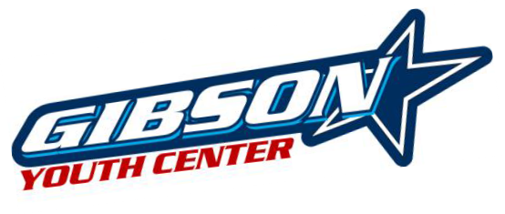Hope for North Brevard Inc. sponsoring the
Gibson Youth Basketball League
2017 Boys & Girls Competitive Basketball

Schedule | Game Days | Boys Divisions
7-8 Games & Tournament | Saturdays from 1/7/17 – 2/25/17 | 7th-9th Grade Boys & Girls (Co-ed)

Location: Gibson Youth Center 835 Sycamore Street, Titusville, FL 32780

Registration: Registration begins Monday, November 21, 2016 and ends Saturday, December 10, 2016
Evaluations: Required/Mandatory evaluations will be on 12/3 and 12/10 at Gibson Youth Center
Cost: $40.00 per player. Includes Registration, T-shirt & Game Day Jersey
Check payable to Hope for North Brevard Inc. To register, fill in the information below and send form
& payment to Hope for North Brevard: 416 Pine Street, Titusville, FL 32796
or register on-line at http://hopenb.org/gibson/gybl/ (pay with PayPal)
Enrollment Limited. Pre-registration is highly encouraged!
Direct inquiries to Gibson Youth Center at (321) 267-1112
or League Director: Mark DeVoss (7th-9th) 321-427-4141

**tear off** (fill out all information – print legibly)

Last Name First Age_____ Gender M / F DOB School Grade Address City Zip
Parent/Guardian Home Phone
Cell Phone Email Parent/Guardian Home Phone Cell Phone Email Emergency contact Emergency Phone
Shirt Size (circle one) Adult S M L XL XXL Youth S M L XL

Parent/Legal Guardian Permission to Participate. Please read and sign below
The undersigned, which hereby represents that he/she is the natural parent (or legal guardian) of does hereby consent to said minor (child) participation in the HNB Inc. programs/activities. The undersigned does hereby assume all risk and hazards incidental to the conduct of this activity whether because of negligence, action or inaction by HNB Inc. or its staff, volunteers or agents during games, practices, and/or transportation to and from those events. The undersigned expressly acknowledge that he/she releases HNB Inc. and its staff, volunteers, agents of any co-sponsoring agency from all liability for any injury, loss or damage connected in any way whatsoever to participation in HNB Inc. activities whether on or off HNB Inc. premises. The undersigned acknowledges that participation in the activity may involve risk of conduct between the participants. HNB Inc. reserves the right to photograph, video, film, or reproduce in any medium, any participant for future use, at no compensation to the participant, parent, guardian or agent.
Emergency Medical Treatment Authorization: Please read and sign below.
I hereby authorize and give my consent for any emergency medical, surgical, or dental treatment for my son/daughter, should it be deemed advisable by a medical doctor or dentist. I understand that this is to avoid undue delay and assure prompt medical attention/treatment and that only a licensed and qualified, medical doctor/dentist will be engaged for such an emergency. Any HNB Inc. officers, coaches, volunteers, or another responsible adult escort is authorized to act on my behalf, ONLY after all reasonable efforts have been made to contact me.

Signature of parent or legal guardian _____________________________________________________Date ____________________

OFFICE USE ONLY: DATE RECEIVED: PAYMENT/CHECK#

